# Solution specs

## Description

The document describes the design of a point-of-sale tool renting store, like Home Depot, that rents big tools.

● Customers rent a tool for a specified number of days.

● When a customer checks out a tool, a Rental Agreement is produced.

● The store charges a daily rental fee, whose amount is different for each tool type.

● Some tools are free of charge on weekends or holidays.

● Clerks may give customers a discount that is applied to the total daily charges to reduce the final charge

## Class diagram

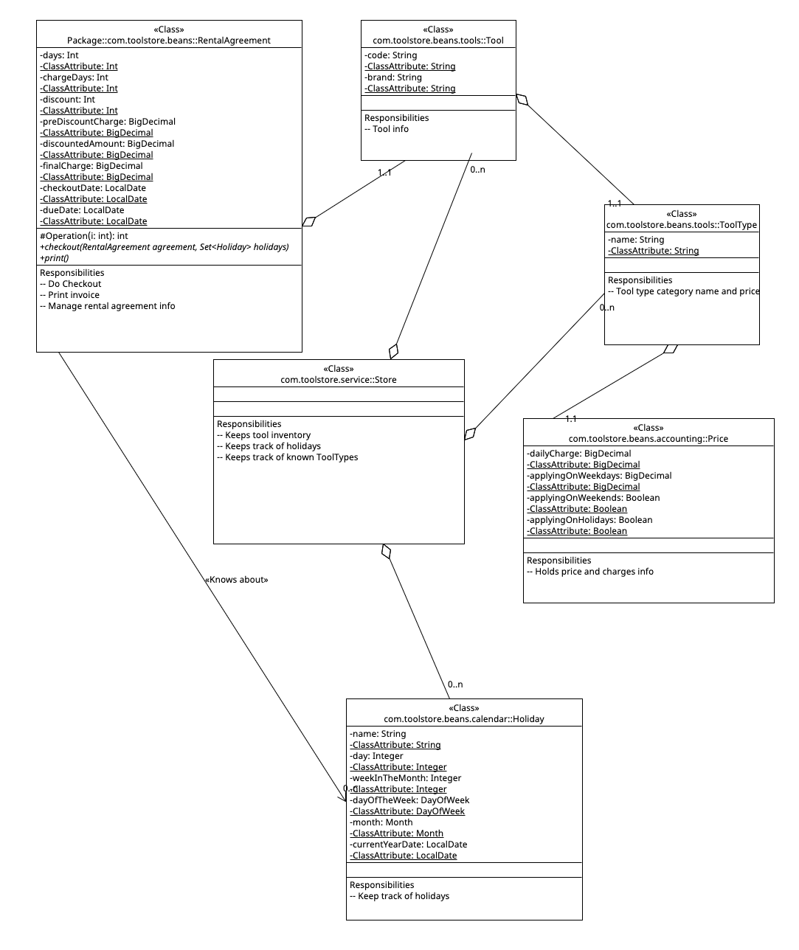

## Business flows

1. Store setup

Create Store -> Setup Holidays -> Setup ToolType -> Add Tools for brand names with specific code

1. Rental agreement

Create Rental Agreement -> Specify Tool -> Specify number of days -> Specify the checkout date and optionally a discount % -> Invoke Checkout to calculate due date, charge days, pre-discount charge, discounted amount and the final charge -> Print the invoice

## Notes

For more info consult the Technical Assessment PDF